CADASTROS E REGISTROS

Tabelas

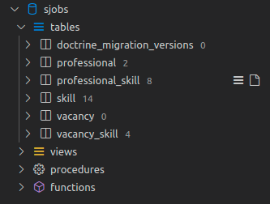

Tabela professional

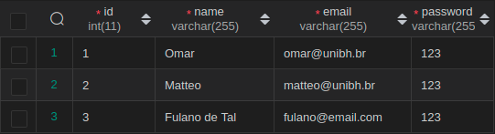

Tabela skill

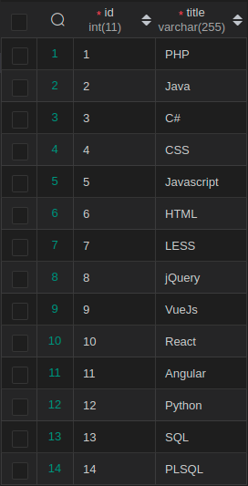

Tabela professional_skill

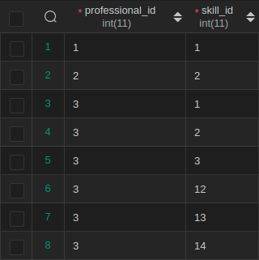

Tabela vacancy

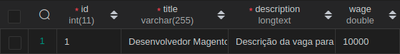

Tabela vacancy_skill

